Manual for using the system:

1. **To use the system, user first needs to register on our website.**
   1. Fill in user name
   2. Fill in password.
   3. Repeat the same password.
   4. Enter your email id.
   5. Fill in Mobile Number.
   6. Fill in the Business Type
   7. Select your gender
   8. Agree to the terms and condition
   9. Click the signup button to successfully register yourself

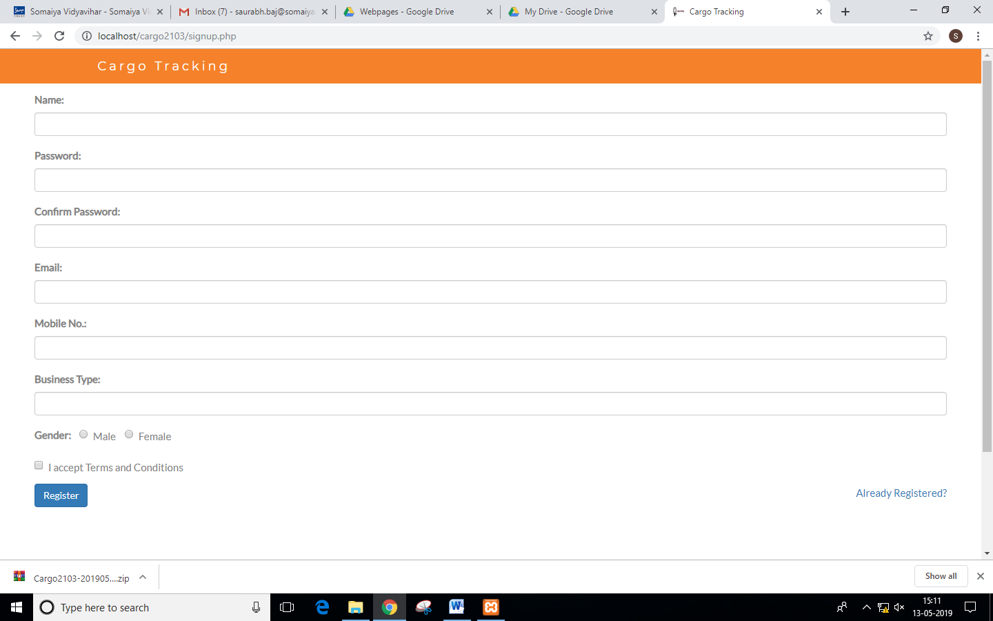

1. **After successful registration, user needs to login with his credentials**
   1. Enter the email and password to login.
   2. Click on the login button to successfully enter the system.

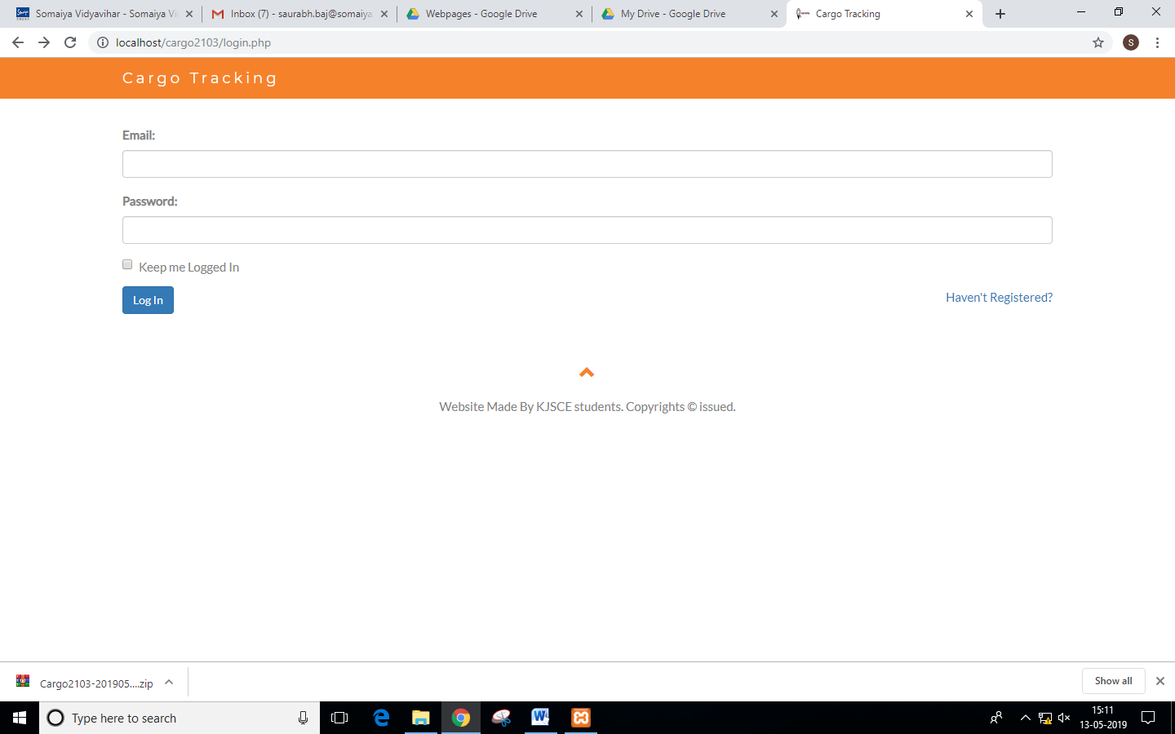

1. **To place an order**
   1. Login to your account.
   2. Enter your email
   3. Select your source location
   4. Select your destination
   5. Select your product type
   6. Enter your product weight
   7. Click on Order to place an order and to get your order number along with an email confirmation of the same.

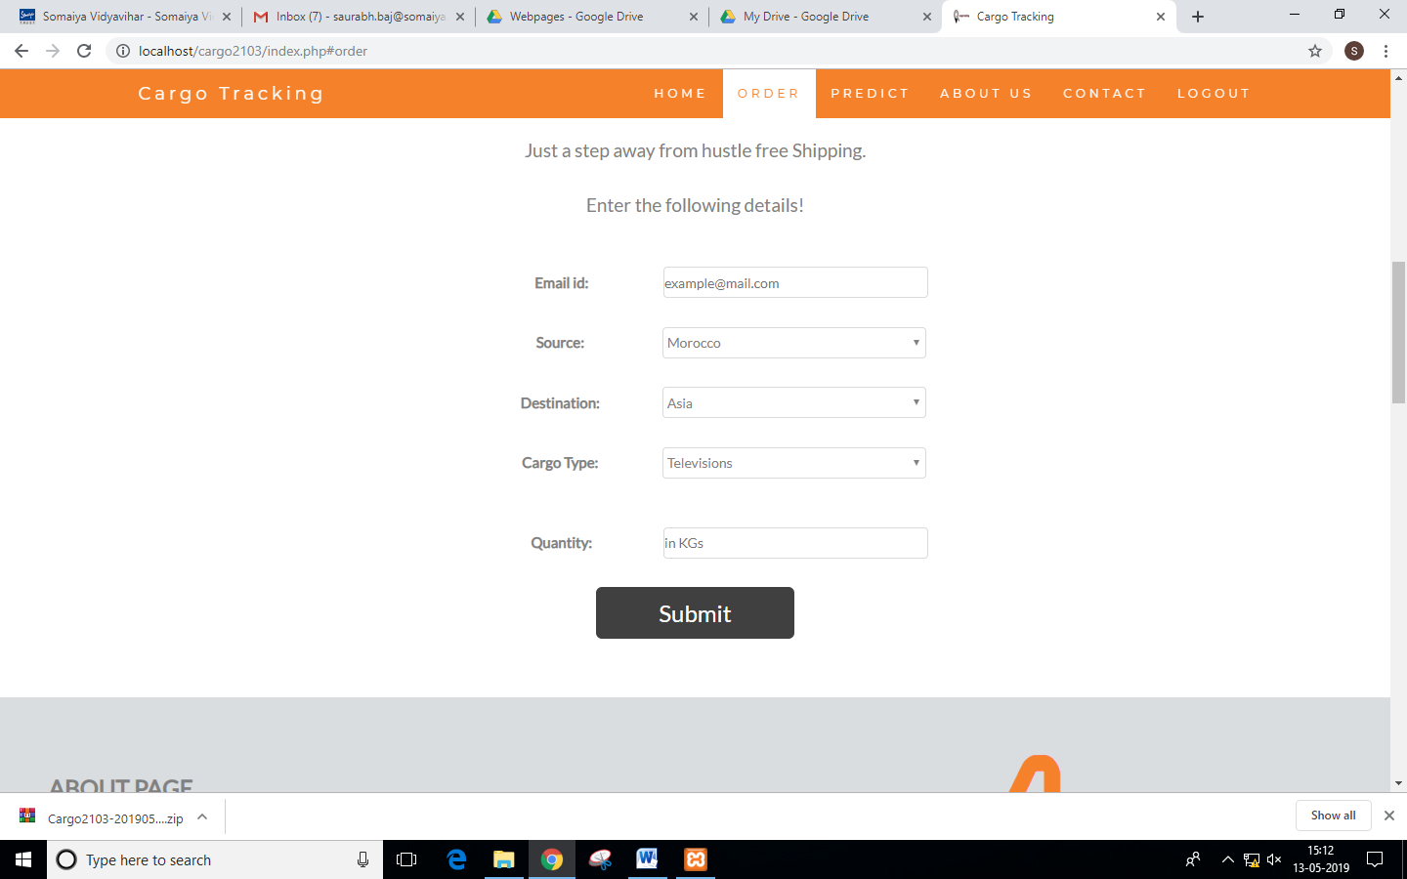

1. **Tracking your order**
   1. Login to your account.
   2. Click on “Track It” button on the homepage.
   3. Enter your order number.
   4. You’ll see the status of your cargo shipment.

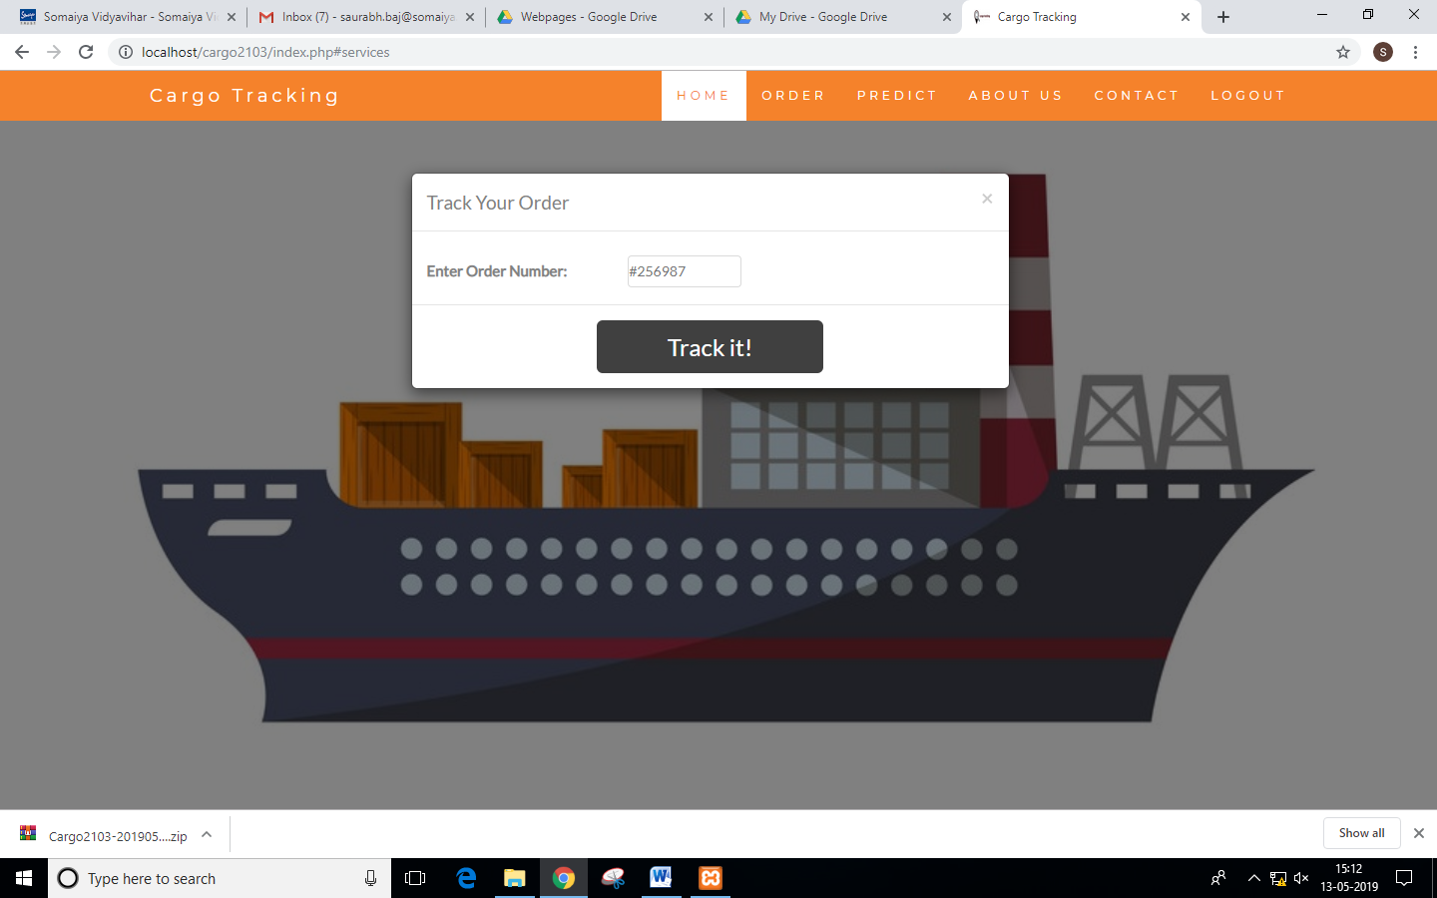

1. **To report any discrepancies**
   1. Login to your account.
   2. Track your order first to confirm your problem.
   3. Click on Notify Us
   4. Elaborate your issue and click Send.
   5. You will be contacted via email about the same.

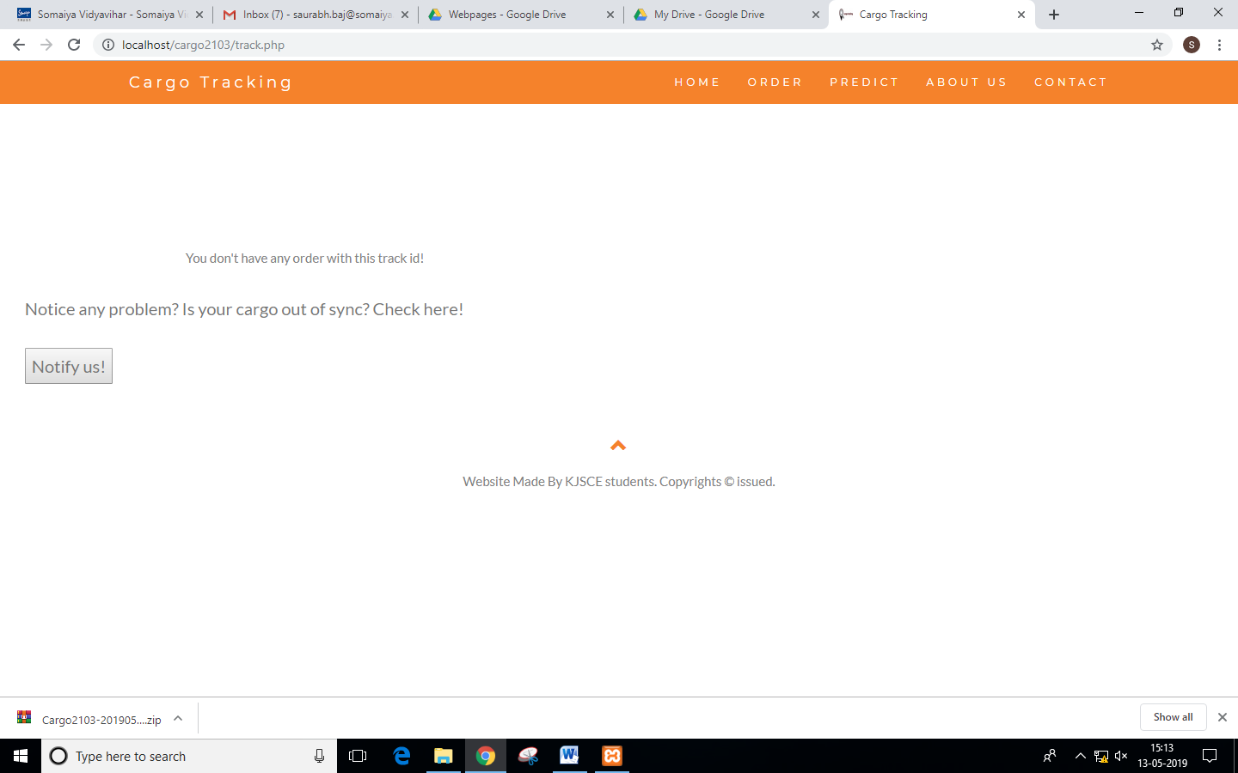

1. **Predict your profit percentage**
   1. Login to your account.
   2. Click on Predict in the header
   3. Select “Predictions” tab
   4. Enter the fields such as Cargo Type, Season, Destination, of your cargo you wish to ship
   5. Profit percentage will be displayed.

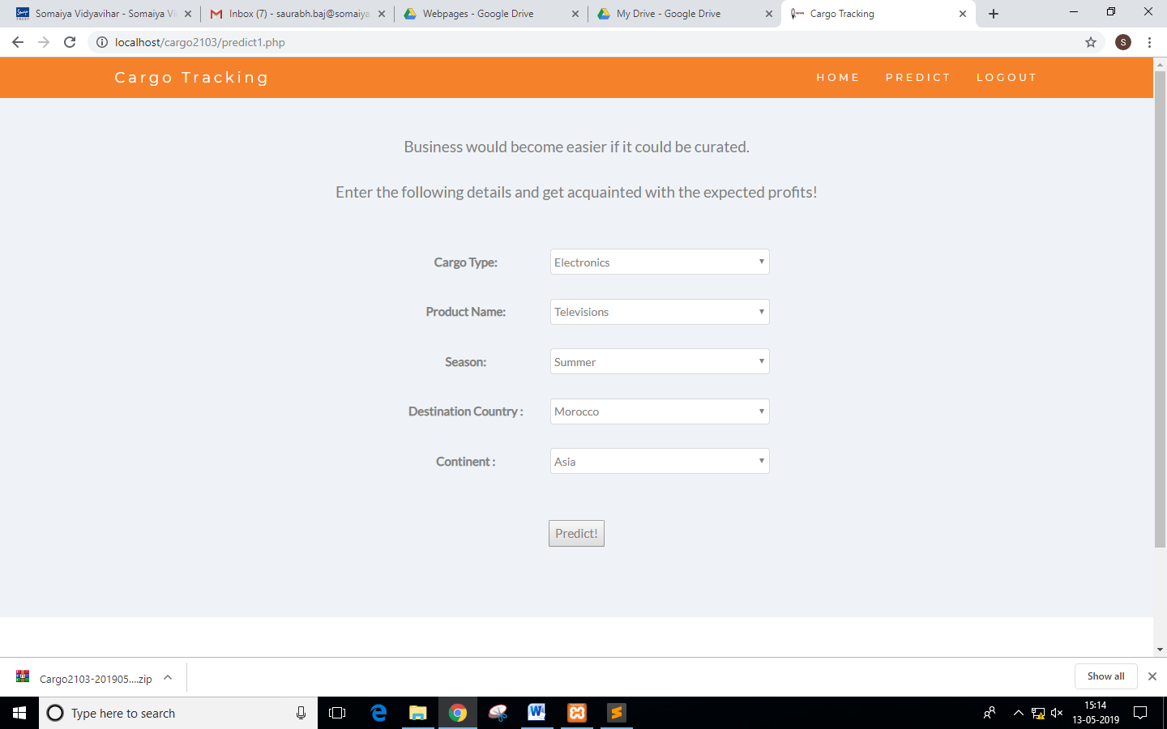

1. **Get suggestions for business expansion**
   1. Login to your account
   2. Click on predict in the taskbar
   3. Select the “Suggestions” tab
   4. Fill the form

